ASSOCIATION OF SCHOOLS OF PUBLIC HEALTH IN THE EUROPEAN REGION ASPHER
Strategic Plan 2020-2025: ASPHER 2025
DRAFT OUTLINE – JUNE 2020
VISION AND VALUES 01
ASPHER 2025: CORE MISSION AND ENABLING AREAS 02
ASPHER 2025: STRATEGIC OBJECTIVES – ACTIVITIES AND OUTPUTS 02
ASPHER 2025: FEE SCHEME 06
ASPHER 2025: MEMBERSHIP BENEFITS AND SERVICES 07
ASPHER 2025: TIMELINE 08

VISION AND VALUES
The Association of Schools of Public Health in the European Region (ASPHER) is the key independent European organisation dedicated to strengthening the role of public health by improving education and training of public health professionals for both practice and research. ASPHER is a membership organisation of institutions, spread across the EU and wider across the WHO European Region, which are collectively concerned with the education and training, and professionalism, of those entering and working within the public health workforce.
The vision of the Association concentrates on the improvement of the health of the population and the planet and the strengthening of professional identity in public health, and thus its main functions include: (1) To support the professionalisation of the public health workforce in Europe, whilst respecting the diversity of national and regional contexts in which each school of public health operates, and thus; (2) To sustain capacity building in public health, so that it balances with national and European population health challenges and threats, and is supported by best standards of public health education and training, scientific research, and practice.
Our values: (1) Member-focused – ASPHER’s strength is in its members, to act as a powerful collective voice for the health of the public in Europe; (2) Diversity – ASPHER supports, enjoys and gains vitality from diversity among its membership; (3) Integrity – ASPHER acts as a whole, undivided and led by strong moral principles, firm ethical considerations and respect; (4) Corporate citizenship – leading by example through ASPHER’s role and responsibilities as a steward for community and planetary health; (5) Europe-centred – grounded in and united by European cooperation and shared European values embodied in the EU and WHO European Region agendas; and (6) Meaningful work – ASPHER maintains focus supporting creative thinking, ensuring coherent action and inspiring innovation.
ASPHER 2025: CORE MISSION AND ENABLING AREAS
The ASPHER 2025 Core Mission Areas include: (1) Education & Training; (2) Applied Research & Service; and (3) Professionalisation.
The following Enabling Areas complement the strategic agenda of the Association: (A) Membership & Governance; (B) Next Generation – Students & Alumni; (C) Partnership & Global Collaboration.
ASPHER is strategically placed to guide cross-country integration of public health training with professional competency-based systems and assessment. Empowering development, support and recognition for professional careers in public health, enables ASPHER and its members to cultivate public health leaders with the passion, skills and capabilities to work effectively in health systems to improve the health of the population and the planet.

ASPHER 2025: STRATEGIC OBJECTIVES – ACTIVITIES AND OUTPUTS
Core Mission Areas
A shared strategic objective across the Core Mission Areas of the ASPHER 2025 agenda is for the Association to become a focal point with a brokering role for its members to support the key functions of schools of public health. The Association will aim to achieve that by setting up the Hub initiative for each of the three Core Mission Areas, i.e.: (1) Public Health Training Hub; (2) Public Health Practical Knowledge & Engagement Hub; and (3) Public Health Career Development & Advancement Hub.
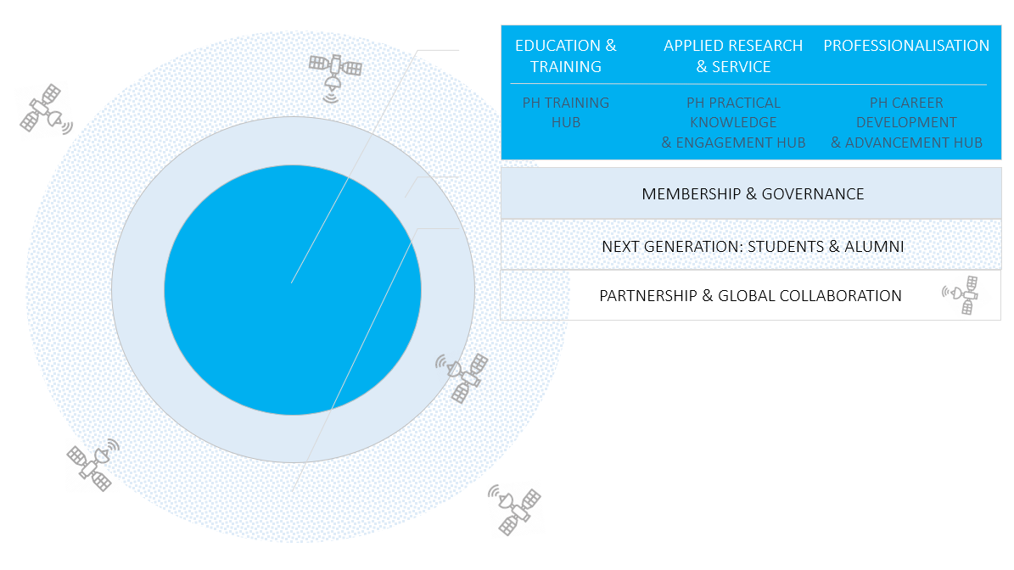
Each of these will be composed of two elements: (i) an online toolkit – being an exclusive component of each and every Hub individually; and (ii) a dynamic element focusing on specific activities “hosted” by the given Hub but serving the context of other areas within the core mission and enabling domains as well, falling within the following three categories respectively: (1) short courses (for the Public Health Training Hub); (2) surveys, guidelines and position statements (for the Public Health Practical Knowledge & Engagement Hub); (3) internship and fellowship schemes, and the Advance Forum (for the Public Health Career Development & Advancement Hub).
Selected functionalities of the Public Health Training Hub toolkit include: directory of available CPD/training offerings, pool of experts/trainers*, and competency-based curriculum creator. Under the short courses component, selected possible training include: SPHs/PHPs leadership and management*, PH crash course; and/or with a focus on other strategy areas: training for PhD supervisors*, training for SPHs/PHPs engaging with the media*, training for advocacy, training for building up PH capacity and PHW professionalisation, and ASSETS (Andrija Stampar Summer Educational & Tutoring School).
Selected functionalities of the Public Health Practical Knowledge & Engagement Hub toolkit include: support to project implementation including bringing together partners for bids and joint publication efforts*, support to schools engaging in work with communities* and a good practice repository. Under the surveys, guidelines and position statements component, selected possible areas of focus include: new sources of data and methods for public health, social accountability and PHET, working with the media, public health erosion – (with case studies*); and/or with a focus on other strategy areas: innovation in teaching and learning, interprofessional PHET for the HiAP/SDGs agenda, diversity in PHET, professional regulation, and mobilization of student and alumni communities – (with case studies*).
Selected functionalities of the Public Health Career Development & Advancement Hub toolkit include competency-based system capacity and individual career planner, including funding opportunities and job bank. The Public Health Career Development & Advancement Hub will also host the Association’s internship and fellowship schemes, and the Advance Forum, linking to the Next Generation – Students & Alumni enabling area of the strategy.
The Core Mission Area of Professionalisation covers also the following programmes and services necessary to support and ensure a well-trained public health workforce fit to work effectively and to lead to improve the health of the population:
Public Health Competencies Programme, the Association’s flagship programme with wide-range functionality via the Core Curriculum – European Core Competences List for the Public Health Professional (academic focus) and the Competency Framework for the Public Health Workforce in the European Region (practice focus).
Public Health Education and Training (PHET) Accreditation – APHEA validation service, the Agency founded and led by ASPHER, serving the Association’s members and contributing to its broader agenda on the PHW professionalisation and PEER service; also to share/develop joint ASPHER-APHEA recommendations for bachelor, master, doctoral programmes and professional training standards.
Professional Credentialing System setup, one of the most challenging agenda items under the ASPHER 2025 strategy aiming at development of Certified in Public Health (CPH) – Europe scheme, taking advantage of its integration with the relevant mechanisms at the global level allowing for the recognition of professional standards in public health across regions.
Code of Conduct draft, complementing relevant efforts under the PHW professionalisation agenda by development and wide endorsement of a Code of Ethics and Professional Conduct for the Public Health Workforce in the European Region.
Public Health Systems Strengthening and Professionalisation Centre, ASPHER-led structure to provide consultancy services to members and other stakeholders including countries via the Professionalisation Road Map roll out (implementation-evaluation-feedback).
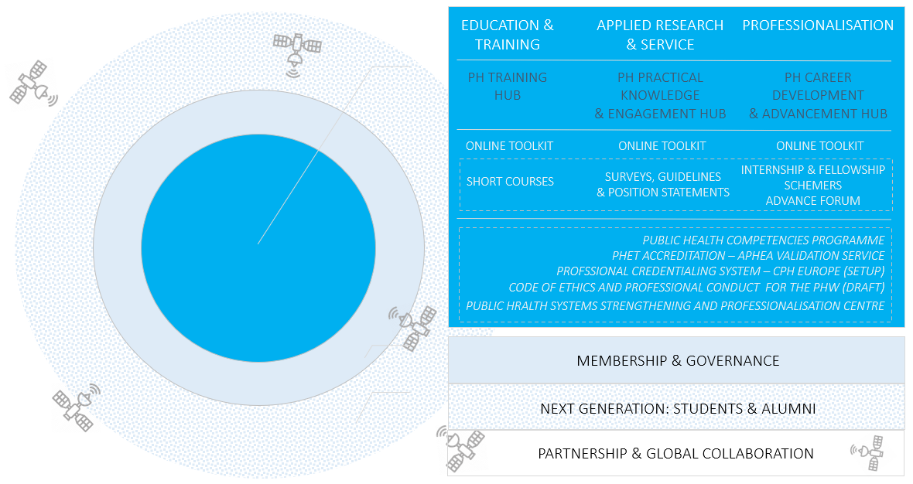
Enabling Areas: Membership & Governance
Membership & Governance is the fundamental enabling area under the ASPHER 2025 agenda. It assumes a number of critical actions to secure the new strategy implementation:
Statutes & Bylaws review (rules of procedure), including roles and responsibilities within the Association’s governance.
Financial routine review, including budgeting and cash-flow, transparency statement – i.e., ASPHER’s guiding principles concerning partnership, sponsorship, and conflict of interest.
Agenda planning routine review, including guidelines for the formulation of presidency priorities, annual work plans, and 5-year strategies; matching capacity.
Membership policy review, including membership benefits and services offer, the fee structure, and other relevant items such as the ASPHER policies on membership capacity building (solidarity scheme and individual country cases); engagement in member and other projects; and on the Association’s collaborating centres, working groups and networks of interest. See the fee scheme and membership benefits and services offer for further consultation later in the document.
ASPHER PEER positioning as a flagship service of the Association to members. Through the Public Health Education European Review (PEER), ASPHER offers a cadre of expertise on the process of international peer review and standards; to evaluate and provide recommendations for planning and improvement. This is not an accreditation service, but it is a flexible offer that may be tailored to specific development and pedagogic/other project needs as identified by ASPHER members.
Public Health Reviews (PHRS) positioning as a society journal.
ASPHER Deans’ & Directors’ Retreat positioning as a key membership event of the Association, including development of a handbook to guide the organisation of the event under a new/enhanced format based on past years’ experience.
ASPHER Honours Committee positioning as the Association’s “reflection chamber”, composed of the ASPHER past presidents and the Andrija Stampar Medallists.
ASPHER Student & Alumni Network setup, to address the context of next generation and early career professionals in public health via communities closest to the Association’s membership, including activities detailed in the following section.
Awards & Distinctions review, including policies referring to the Andrija Stampar Medal and ASPHER Deans’ and Directors’ Good Practice Award in Public Health Education and Training; with additional awards/distinctions to be considered.
ASPHER website & social media channel positioning, achieving greater impact.
Enabling Areas: Next Generation – Students & Alumni
A representative of ASPHER’s SAN will join the ASPHER Executive Board in an advisory capacity.
Activities under the Next Generation – Students & Alumni enabling area of the ASPHER 2025 agenda form the portfolio of the Association’s Students & Alumni Network (SAN), and include:
ASPHER Advance Forum*, hosted online by the Public Health Career Development & Advancement Hub (to facilitate exchanges among members for practical experiences/ placements, thesis supervision and examination) and by the annual Deans’ & Directors’ Retreats.
ASPHER Young Researchers’ Forum, hosted by the annual European Public Health Conference as standard, possible other contexts such as Digital Public Health (DPH) and/or European Scientific Conference of Applied Infectious Disease Epidemiology (ESCAIDE).
ASPHER Internship & Fellowship Schemes*.
ASSETS (Andrija Stampar Summer Educational & Tutoring School).
ASPHER SAN consultancy service* on how to mobilize student and alumni communities (stand alone and as an integrated part of the PEER service).
Enabling Areas: Partnership & Global Collaboration
The final enabling area of the ASPHER 2025 agenda refers to Partnership & Global Collaboration. The general approach here is two-fold:
- Europe-level via the WHO EURO Coalition of Partners (COP) and the EU Health Policy Platform (HPP);
- Global-level via the Global Network for Academic Public Health (bringing together ASPHER-like networks from all regions, with TIPH campaign) and via the World Federation of Public Health Associations (WFPHA).
Selected core partnerships and collaboration arrangements within the individual areas of ASPHER 2025 include:
For Education & Training: Agency for Public Health Education Accreditation (APHEA).
For Applied Research & Service: European Observatory on Health Systems and Policies (OBS), European Public Health Alliance (EPHA) and European Public Health Conference of the European Public Health Association (EPH-EUPHA).
For Professionalisation: Int Association of National Public Health Institutes (IANPHI).
For all three of the Core Mission Areas – serving the Hub initiative, but also selected activities under the Enabling Areas: Public Health Reviews (PHRS).
For Next Generation – Students & Alumni: European Network of Medical Residents in Public Health (Euronet MRPH), and other relevant student and young professional networks such as the Europubhealth+ Students and Alumni Association (EPHSA).

ASPHER 2025: FEE SCHEME
Key features of the new fee structure proposal:
- Full Members fee: 750 – 2500 EUR; calculated based on 2 criteria: (1) Size of the school; and (2) GDP of the country of establishment.
- Associate Members fee: flat rate of 1000 EUR.
Institutional members only, i.e. schools from outside of the WHO European Region. Individual Membership will no longer be offered.
- Special fee category for country-level structures representing more than one institution under the condition of at least 2 institutions remaining in direct membership arrangement with the Association); and other structures with a role in Public Health Education and Training (PHET): 4000 EUR.
- Two years of transition period for members that fall within the higher fee category under the new fee structure proposal.
- Supporting membership contribution – a voluntary contribution/donation separate from the mandatory membership fee scheme; towards a specific programme, strengthening secretariat capacity, building reserves and/or solidarity scheme.
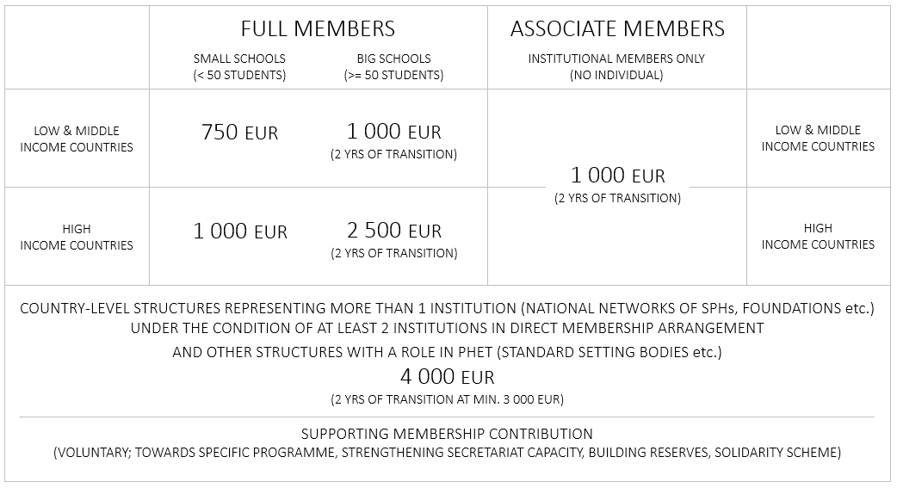

ASPHER 2025: MEMBERSHIP BENEFITS AND SERVICES OFFER
(to be refined with additional details and logical order to distinguish between benefits and services)
Being a part of the ASPHER network – membership community.
Active and passive voting rights on Association’s matters /General Assembly.
Taking part in consultation and further implementation of ASPHER agenda
(including strategy and annual work plans).
Joint project opportunities with the Association; also ASPHER engaging in projects and other initiatives only if membership link/interest is established.
Invitation to Annual Retreat.
Access to ASPHER PEER service.
Access to ASPHER task forces, working groups and networks of interest.
Possibility to apply for the ASPHER collaborating centre status.
Access to full functionality of the ASPHER Hub Initiative (PH Training Hub, PH Practical Knowledge & Engagement Hub, and PH Career Development & Advancement Hub).
Access to ASPHER Student & Alumni Network – SAN (including Advance Forum, and Fellowship & Internship Schemes).
Access to ASPHER partnerships, including the Global Network for Academic Public Health.
Access to This Is Public Health – Europe campaign.
Access to ASPHER awards and distinctions (passive and active voting status).
Access to ASPHER's premises and representation in Brussels.
Access to the online platform – online community membership at aspher.org, and to other communication platforms of the Association (social media, monthly newsletters, journal…).
Access to ASPHER consultancy services via the Association-led Public Health Systems and Professionalisation Centre and/or Students & Alumni Network – SAN.
Discounts to publish in Public Health Reviews (PHRS); access to PHRS editorial board.
Discounts in APHEA rates and the validation service at the point of entry to the Association, also access to APHEA pool of reviewers.
Discounts in EPH Conference rates, and other benefits linked to possible exposure in the context of the conference (joining ASPHER-led sessions, exhibition booth…).

ASPHER 2025: TIMELINE
 | 2020 | 2021 | 2022 | 2023 | 2024 | 2025
EDUCATION & TRAINING |  | HUB PROJECT LAUNCH (SOFIA 2021)
APPLIED RESEARCH & SERVICE |  | HUB PROJECT  LAUNCH (SOFIA 2021)
PROFESSIONALISATION | COMPETENCIES PROGRAMME  NEW AGENDA  ASPHER-APHEA POSITIONING  (VIRTUAL GA) | HUB PROJECT  LAUNCH (SOFIA 2021)  CPH EUROPE FEASIBILITY STUDY | CODE OF CONDUCT (DUBLIN 2022)  CPH EUROPE FEASIBILITY STUDY (CONT.) | ASPHER 2025 MID-TERM EVALUATION
MEMBERSHIP & GOVERNANCE | PHRS POSITIONING  PEER  POSITIONING  HONOURS COMMITTEE POSITIONING  (VIRTUAL GA) | REVIEW POINTS  (SEE: PP.4-5)  ASPHER WWW  UPGRADE  (SOFIA 2021) | DD RETRRAT POSITIONING (DUBLIN 2022)
NEXT GENERATION: STUDENTS & ALUMNI |  | SAN SETUP  (SOFIA 2021)
PARTNERSHIPS & GLOBAL COLLABORATION | GLOBAL NETWORK FOR ACADEMIC PH LAUNCH  TIPH EUROPE POSITIONING | ASPHER-EPH CONFERENCE POSITIONING
DEANS’ & DIRECTORS’ RETREAT /  GENERAL ASEMBLY | VIRTUAL  (JUN-SEP) | SOFIA | DUBLIN
PRESIDENCY &  EXECUTIVE BOARD | MIDDLETON  CZABANOWSKA  BARROS  BUCKINGHAM  CODD  KUNZLI  LYUBOMIROVA  RAZUM  SIGNORELLI | MIDDLETON  SIGNORELLI  CODD  RAZUM  …  …  …  …  … | SIGNORELLI  MIDDLETON  …  …  …  …  …  …  … | SIGNORELLI  …  …  …  …  …  …  …  … | …  SIGNORELLI  …  …  …  …  …  …  … | …  …  …  …  …  …  …  …  …

Annual work plans (for the following year) will be presented each year at the General Assembly, and preliminarily approved; subject to confirmation via online vote in Q4.
Mid-term evaluation scheduled for the period between 2022-2023 Retreats/General Assemblies.

Activities and outputs remaining exclusive to ASPHER members are marked with “”
Activities and outputs remaining exclusive to ASPHER members are marked with “”

