



ASPHER Report: COVID-19 Situation Reporting across Europe

Week of November 14th, 2022

Authors: Rok Hrzic^{1,2,3}, Nadav Davidovitch^{3,4*}

¹ Maastricht University, the Netherlands
² ASPHER Young Professional
³ ASPHER COVID-19 Task Force
⁴ Ben-Gurion University of the Negev, Israel

Corresponding Author: nadavd@bgu.ac.il

This is ASPHER’s weekly surveillance report. We hope it is complementary to other resources such as ECDC and Our World in Data, where the reader can go for more detailed information. Please give us your feedback: is the presentation helpful to you and your colleagues? What other information would you like to see in it?
Key messages
- The WHO weekly epidemiological update highlights that the global number of new weekly COVID-19 cases increased by 2% while the number of deaths declined by 30% over the previous week.
- The ECDC country overview report highlights decreasing trends in the EU/EEA case rate, the case rate among people aged 65 years and older, and the death rates. At the EU/EEA level, hospital and ICU indicators have remained stable in comparison to the previous week. In many EU/EEA countries, the vaccination uptake for the second booster dose remains low in target groups.

ASPHER statement on the pandemic
ASPHER is concerned about talk of the ‘end of the pandemic’. Pandemic is not defined by politicians, or by journalists. The pandemic is defined by the World Health Organisation, under strict decision-making process and not as mere opinion. A pandemic is “an epidemic occurring worldwide, or over a very wide area, crossing international boundaries and usually affecting a large number of people”. We are still in the midst of the pandemic.

We are concerned with the rapid dismantling of non-pharmaceutical interventions against COVID-19 across Europe. In a recent opinion paper, we advocate for European governments’ continued recommendation for the use of face masks in high traffic public areas like public transport. The reality remains that the future evolution of the pandemic is highly uncertain. Primary health care and social care provision across Europe are not yet restored to pre-pandemic levels due to the burden of ever new variants of the virus. Occupational health services are non-existent in many parts of Europe and therefore unable to address mass sickness absence or support workers in key industries suffering burnout. We urge governments to invest in additional measures to support primary care, social care, and occupational health. Protection of our key service workers is a central concern. We will not come out of the pandemic until we seriously address the problem globally. We need global solidarity, commitment to international preparedness and increased global production of vaccines.

ASPHER supports the VACCINE-plus approach to pandemic control; or what we have called ‘COVID-DO_IT_ALL’. We recognize the importance of following non-pharmacological interventions as well as achieving a high level of vaccine uptake. Vaccine hesitancy still needs to be understood and addressed especially in Eastern parts of Europe. We need to protect frontline services, protect children, and protect vulnerable people. Current political moves in Europe are adding to the likelihood of increased transmission, creating more pressures on services, more likelihood of additional sickness absence, economic damage, and social disruption. The mindset of the ‘pandemic is over’ will have the dangerous impact of prolonging it.

Rolling average of latest COVID-19 death and hospitalization rates in the countries of the WHO-Europe region (Source: Our World in Data).

WHO Europe region | Daily newly confirmed COVID-19 deaths/million people | 30-day trend in deaths | Weekly hospital admissions/million | 30-day trend in weekly hospital admissions
Finland | 4.43 | 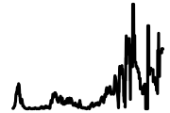 |  | 
San Marino | 4.24 | 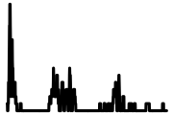
Monaco | 3.92 | 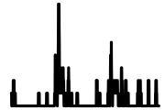
Hungary | 2.48 | 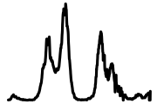
Iceland | 2.30 | 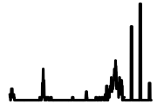 | 24.40 | 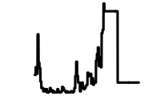
Belarus | 2.10 | 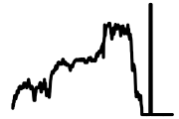
Greece | 1.87 | 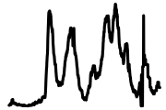 | 136.82 | 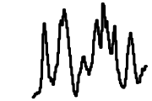
Andorra | 1.79 | 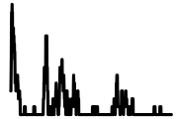
Germany | 1.74 | 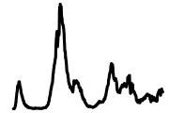 | 67.41 | 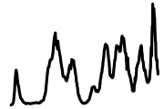
Cyprus | 1.59 | 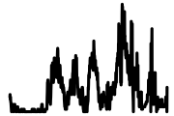
Sweden | 1.41 | 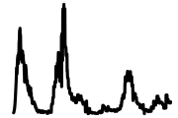
Croatia | 1.35 | 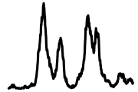 | 127.84 | 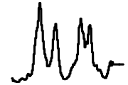
Italy | 1.33 | 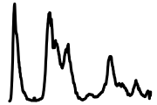 | 53.00 | 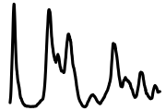
Slovakia | 1.11 | 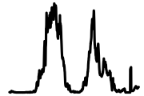 | 37.73 | 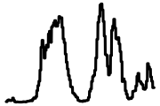
Denmark | 1.04 | 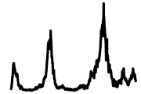 | 42.16 | 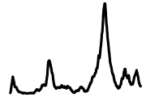
Estonia | 0.97 | 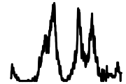 | 117.29 | 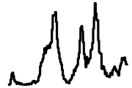
Ireland | 0.97 | 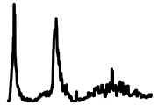 | 66.12 | 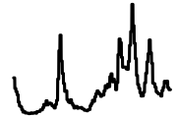
Austria | 0.90 | 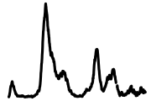
Luxembourg | 0.88 | 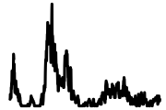 | 22.06 | 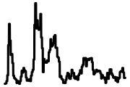
France | 0.83 | 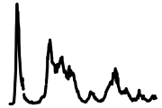 | 64.26 | 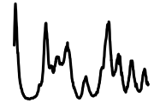
Bulgaria | 0.82 | 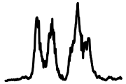 | 673.17 | 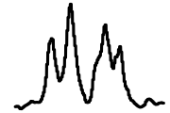
Czechia | 0.79 | 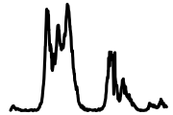 | 44.41 | 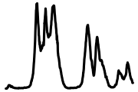
Portugal | 0.74 | 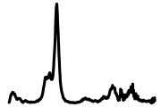
Slovenia | 0.67 | 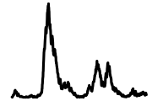 | 40.78 | 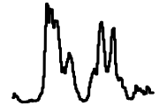
Lithuania | 0.62 | 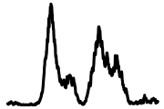
Serbia | 0.62 | 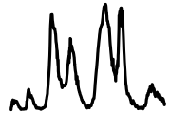
Spain | 0.55 | 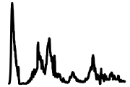 | 60.68 | 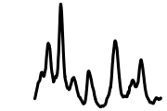
Belgium | 0.50 | 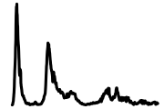 | 31.83 | 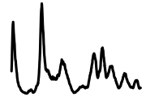
Georgia | 0.46 | 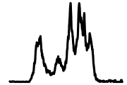
Ukraine | 0.44 | 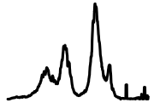
Russia | 0.42 | 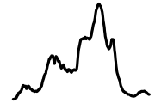 | 51.00 | 
Malta | 0.27 | 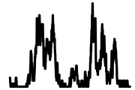 | 9.69 | 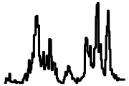
Bosnia and Herzegovina | 0.26 | 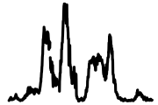
Israel | 0.26 | 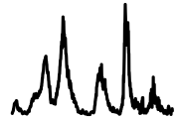 | 23.18 | 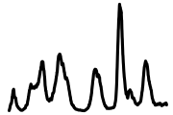
Moldova | 0.26 | 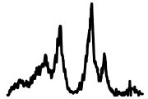
Netherlands | 0.24 | 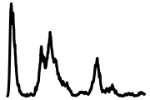 | 28.70 | 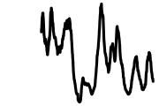
Montenegro | 0.23 | 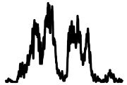
North Macedonia | 0.20 | 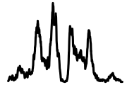
Switzerland | 0.20 | 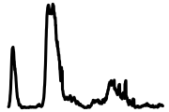 | 21.40 | 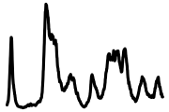
Romania | 0.19 | 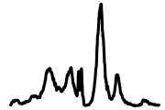
Poland | 0.18 | 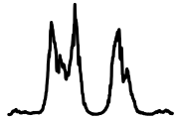
Armenia | 0.15 | 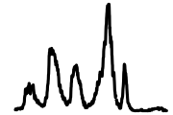
Azerbaijan | 0.11 | 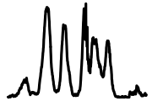
Kosovo | 0.08 | 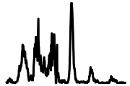
United Kingdom | 0.07 | 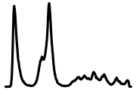 | 58.69 | 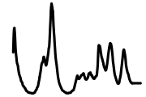
Albania | 0.05 | 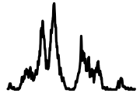
Turkey | 0.04 | 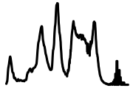
Kyrgyzstan | 0.02 | 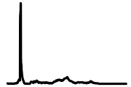
Kazakhstan | 0.01 | 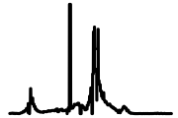
Tajikistan | 0.01 | 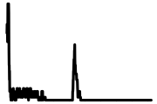
Uzbekistan | 0.01 | 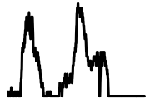

The age-standardised all-cause death rates in 2020, 2021 and 2022, and the 2015-2019 average by week and sex in selected countries of the WHO-Europe (Source: Human Mortality Database).

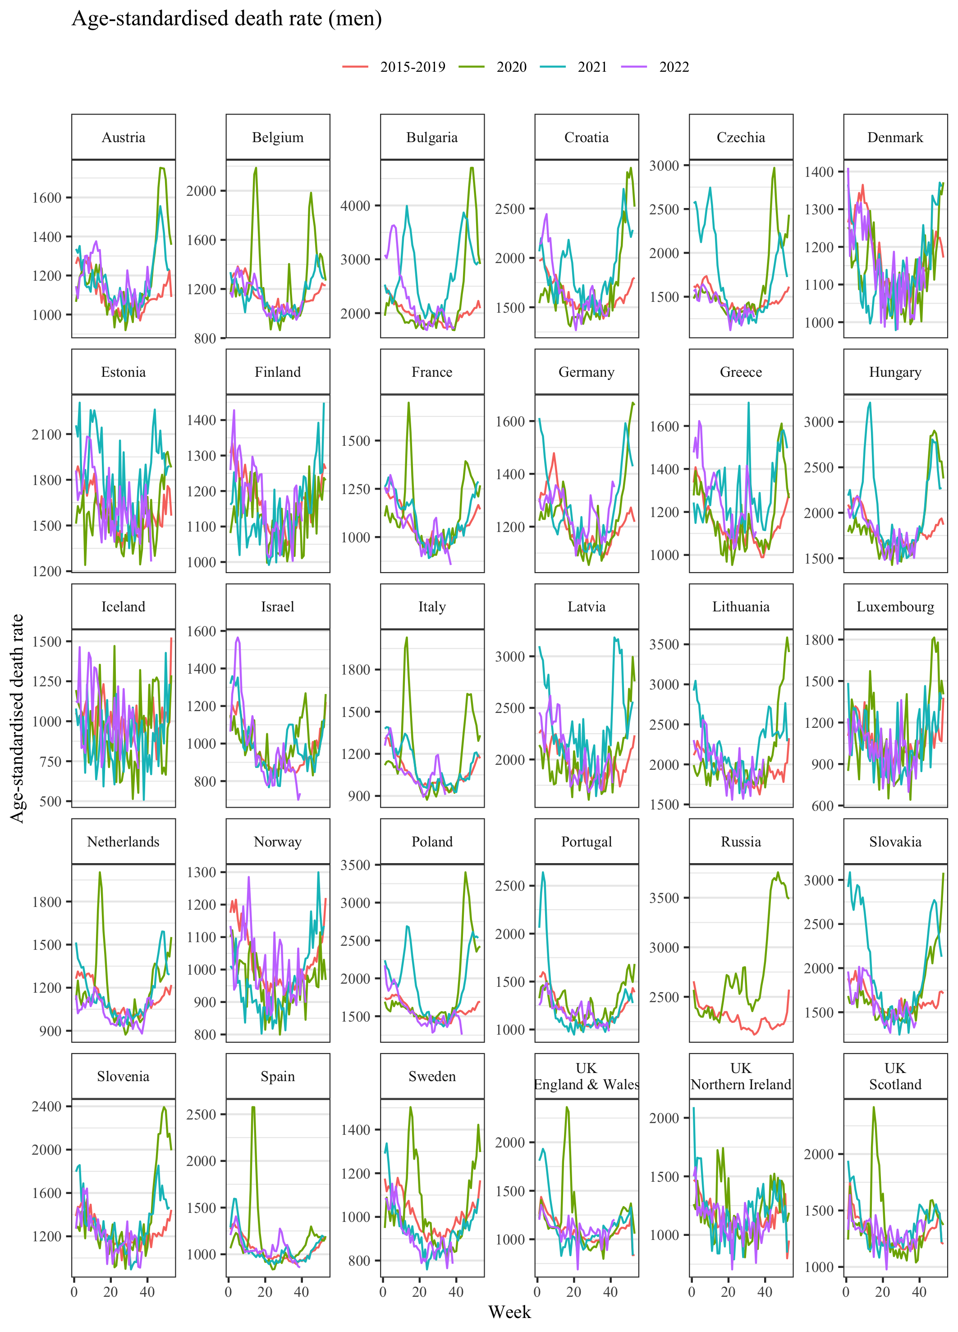
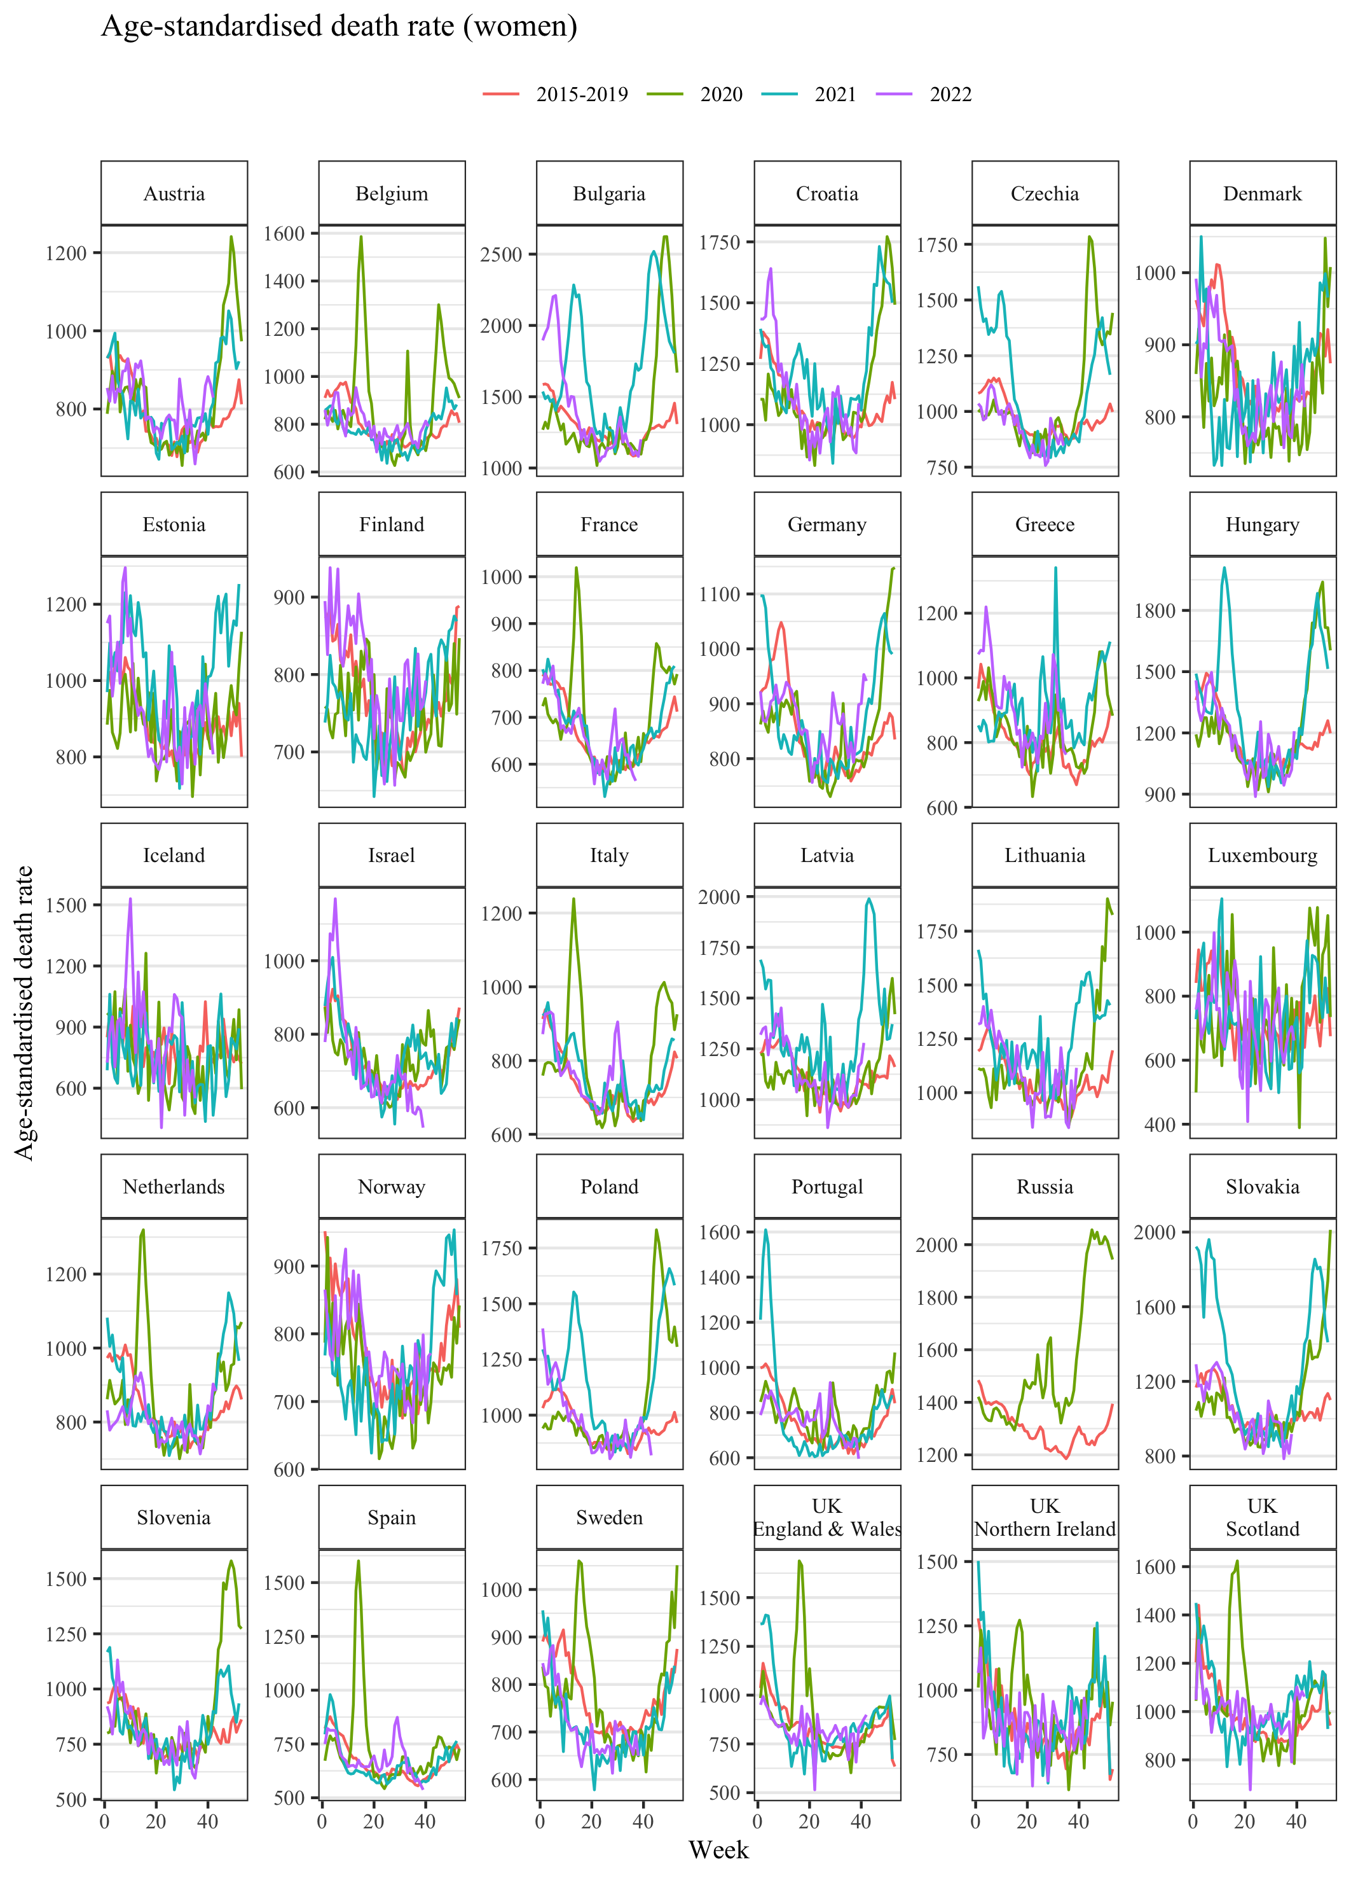

Rolling 7-day average of daily confirmed COVID-19 death rates (per million) in sub-regions of Europe (Source: Our World in Data).

